(Approx. 1,128 words)


3 Better Ways to Store Your Files than On the Desktop
By Joel Lee, MakeUseOfCom.com,
May 5, 2014
http://www.makeuseof.com/tag/3-better-ways-store-files-desktop/
http://bit.ly/1iiLU2u

Did you know that storing files directly on your desktop can harm your productivity? I used to be one of “those” people who downloaded files straight to the desktop. If you can identify with that, then I have good news for you: you can do better. Desktop storage is simple, sure, but it comes with hidden drawbacks you may not know about.

Kick the bad habit with these alternative file storage methods. They may not be as convenient but I promise that you’ll learn to love them in the long run.
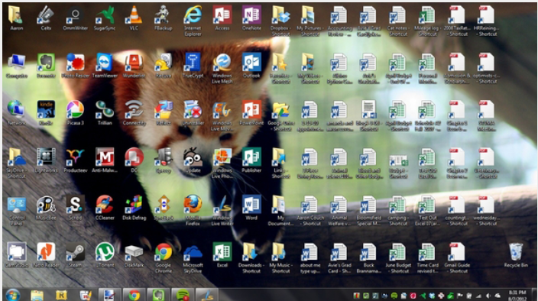
The urge to save files to the desktop is understandable. It provides immediate access with a single click, which means that it’s tempting to turn the desktop into a de facto headquarters for storage. But unless you are strict with maintenance, you’ll eventually succumb to these issues:

- No file protection. As noted by PC World, certain directories are not affected by System Restore, the most recognizable location being My Documents. Files on the desktop are affected by System Restore, which can result in unexpected file disappearances.
- No file backups. Many file backup programs ignore desktop files by default. Most programs worth their salt will allow you to change the settings and include the desktop if necessary, but all it takes is one forgetful moment to accidentally lose an important desktop file.
- Clutter, clutter, clutter. The story is always the same. You begin your desktop collection with a few documents. Over time, the collection grows to include images, music, programs, zip files, and more documents. Suddenly, finding the right document takes more time than actually opening it.

Separate Drive Partitions
One bit of computer wisdom that you should learn is this: “Never save data on the same partition as your operating system.” In Windows, the location of the desktop on the file system does reside on the same partition as the operating system itself.

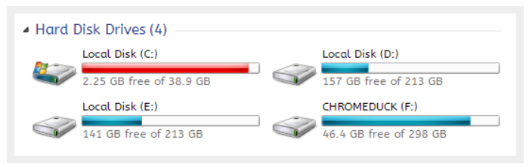
Why is this important advice? Because you want to avoid putting all of your eggs in the same basket.

Let’s say that you happen to contract a mild virus or malware that attacks your operating system. It might wipe all files related to the operating system itself OR it may affect the entire partition that holds the operating system. By losing the operating system, you lose all of your saved data as well.

But if you installed Windows to the C: partition and stored all of your files on the D: partition, your files on D: would be safe even if C: were wiped clean. The only way D: would be affected is if the physical hard drive itself was wiped or damaged.

One additional benefit of having separate partitions is that you can reinstall Windows without losing your saved data. Tina has written on the subject of resizing Windows partitions, so check it out if you want to take advantage of this feature. http://bit.ly/1lfBCDe

Use Windows Libraries
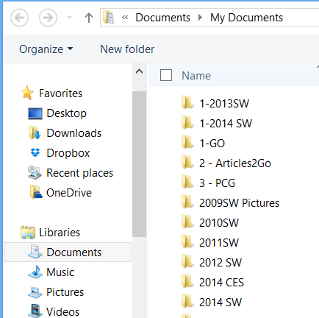
Every installation of Windows comes with a directory called My Documents. In Windows 7, it was renamed to Documents and came with a couple of buddies: Music, Pictures, and Videos. They’re called libraries and you’ve probably seen them before, but never really used them, right? Well, you should reconsider.

In truth, these four libraries are special. They aren’t just directories; they’re collections of multiple directories. In each library, you can specify different directories to be included and that library will show the content from all included directories. It sounds more complicated than it is.

Think of it like this: You can save your videos to many different locations and link those directories to the Videos library. Then, whenever you access the Videos library, you’ll see all of those files in one place.

It’s just as convenient as storing everything on the desktop, yet infinitely more flexible and organized. For more details on how to take advantage of this feature, check out Chris’s writeup on how to use Windows Libraries. http://bit.ly/1iMkORF

Store Files in the Cloud
Cloud storage has been a big buzz term over the past few years and for good reason. While cloud-related solutions like Dropbox, G+ Drive, or Microsoft OneDrive come with

privacy concerns <http://bit.ly/1lzsQ4F>, they also offer many benefits and I think people are too quick to throw the baby out with the bathwater.


Here’s how it works: You set aside one or more directories that automatically sync with whatever service you’re using (comparison of cloud storage services). These files can be accessed from anywhere and they can be set to private or public.

Why is this better than storing straight on the desktop?

- Immediate backups. Due to automatic synchronization, you rarely need to worry about lost files. If your computer gets wiped somehow, those files still reside on the cloud and you can always retrieve them again.
- Revision history. Not every cloud service offers a revision history, but most do and it’s an important feature. Basically, the service will track every change that’s made to the file (it may be limited to the last X changes) and allow you to instantly revert to a past version if necessary.

One Drive (aka SkyDrive) comes integrated with Windows 8 and can help you keep your files synced.

Need Quick Access to Files?
Sometimes convenience wins out over practicality and reason. The desktop is great because it allows for immediate access, right? With one small compromise, you can maintain that convenience. The answer is to use shortcuts.

Creating a shortcut is as simple as dragging a file using the right mouse button to where you want the shortcut to appear, then selecting Create shortcut here from the menu. Even if a shortcut gets wiped, the actual file will still be safe.

But instead of putting the shortcuts on the desktop, why not take it one step further?

Right click on any file shortcut and select either Pin to taskbar or Pin to start menu. It’s a self-explanatory feature that works just as well as, if not better than, traditional desktop shortcuts. I use it day in and day out and I wouldn’t have it any other way.

Conclusion
Ultimately, personal preference will always win. For those of you who have been “desktopping” for years, you’ll probably find it near impossible to break the habit. I still do it from time to time, though I try my best to clean up after myself when I realize what I’m doing. It just doesn’t make sense to store everything on the desktop anymore.

Do you clutter up your desktop with files and folders galore? If so, are you convinced enough to try a safer method of file storage? Share your thoughts with us in the comments! http://www.makeuseof.com/tag/3-better-ways-store-files-desktop/

